**EMBEDDED SYSTEM PROJECT**

**(**EE3401)

*Electrical Engineering Project submitted to the*

***National Institute of Technology Rourkela***

*In partial fulfillment of*

***Bachelor in technology*** *in*

***Electrical Engineering***

*By*

ANUP ASHISH DASH-122EE0595

SOUMYA SOURAV-122EE0384

SANSKRUTI DASH-122EE0596



*Under the supervision of*

***Dr. Supratim Gupta***

*Department of Electrical Engineering*

***National Institute of Technology Rourkela***



**PROBLEM STATEMENT:**

We want track Sun automatically and position the solar panel to get maximum solar energy conversion into electrical energy.

**ABSTRACT:**

This research focuses on a Dual-Axis Sun TrackingSolar Panel System aimed at maximizing solar energy conversion. The system uses sensors to track the Sun’s movement and adjust the panel's orientation for optimal energy absorption. By incorporating dual-axis tracking, the panel captures sunlight from multiple angles, increasing efficiency. The system is controlled by a microcontroller and simulated using Proteus software. Future enhancements include integrating a notification system to alert users about battery levels and system performance, improving the monitoring and management of solar energy systems.

**I.OBJECTIVE:**

The primary aim of this experiment is to develop a Dual-Axis Sun Tracking Solar Panel System named LUMI, which automatically tracks the sun's movement and adjusts the solar panel’s orientation to maximize solar energy absorption and conversion into electrical energy.

The key objectives are:

1. **Automatic Sun Tracking**: To create a system that automatically adjusts the solar panel’s position based on the sun’s position throughout the day, ensuring optimal exposure to sunlight and maximizing energy efficiency.
2. **Dual-Axis Tracking Mechanism**: To design and implement a dual-axis tracking mechanism using two motors and Light Dependent Resistors (LDRs) for precise tracking of the sun in both horizontal and vertical directions.
3. **System Simulation Using Proteus Software**: To simulate the entire tracking system using Proteus software, providing a virtual demonstration of the system's functionality, validating the performance of the sun tracking mechanism, and identifying areas for improvement before hardware implementation.

**II. Hardware and Software Requirements**

**Hardware**

* 5mm LDR
* 8051 Microcontroller (AT89S52)
* RS232 IC
* 5V Solar Panel
* 12V DC Motor
* LM293D Motor Driver
* Op Amp
* LED
* 12V Battery
* Resistors
* Potentiometer
* M4 Screws, Bolts, and Washers
* Breadboard
* Jumper Wires
* Soldering Iron
* Glue Gun
* Wire Cutter

**Software**

* SolidWorks
* Proteus

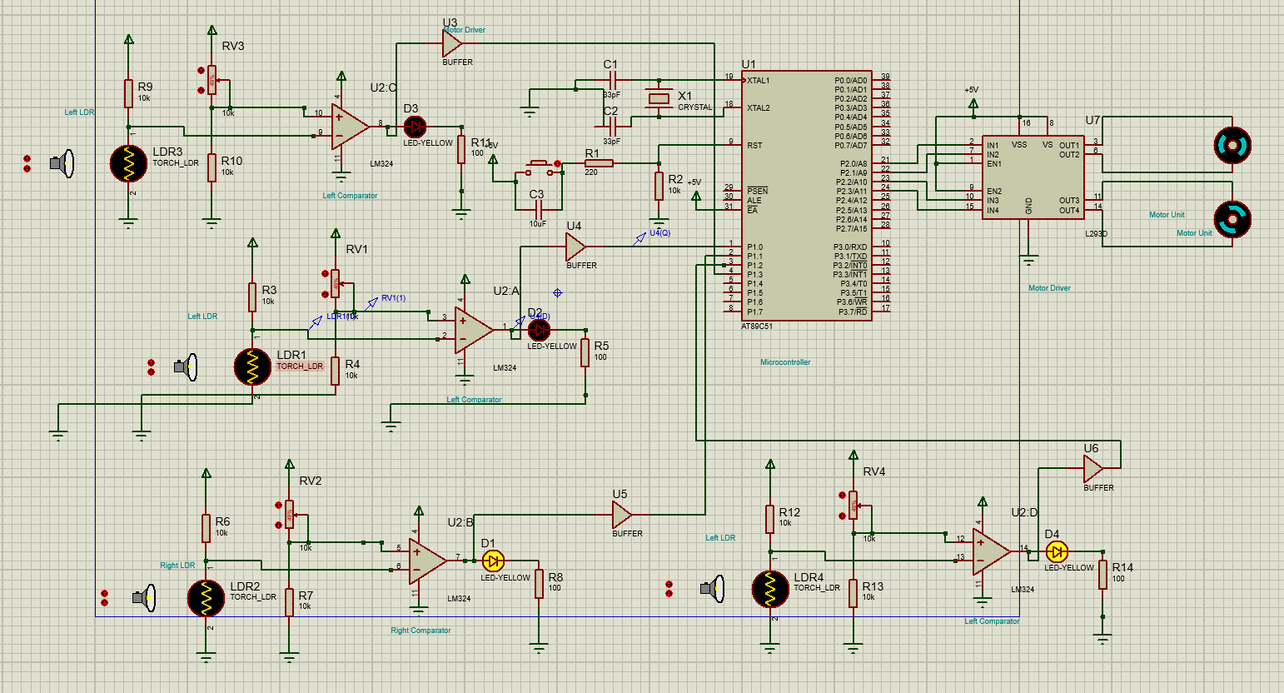

**Figure 1: Schematic of the proteus design**

**Figure 2: Hardware Implementation**

**IV.COMPONENT DESCRIPTION**

**8051 Trainer Kit :-**

The 8051 Trainer Kit is designed to enhance learning and facilitate the development of microcontroller-based projects using Intel and NXP MCUs. This standalone system enables programming and testing without requiring a PC. It allows connection to a standard 101/104-key PC keyboard for inputting user programs in Assembly language. The kit supports programming in both Assembly and C languages and features serial communication capabilities.

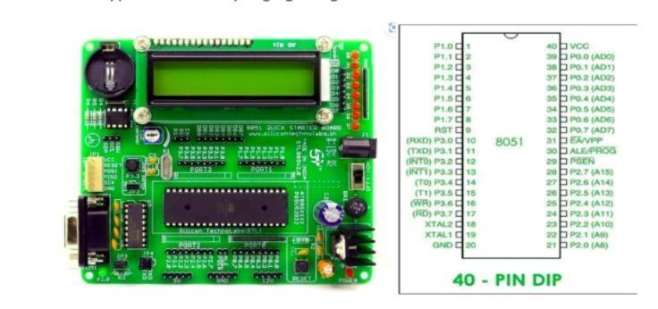

Key Features of the Trainer Kit

* Microcontroller: AT89S52-based development board.
* Integrated Components:
  + MAX232 for serial communication.
  + On-board 16x2 alphanumeric LCD display with adjustable contrast.
  + DS1307 Real-Time Clock (RTC) module.
* Power Supply: Includes an on-board 5V voltage regulator.
* Additional Features:
  + Port expander for enhanced functionality.
  + Reset button for system reinitialization.
  + Eight LEDs to indicate the logic state of pins.
  + RS-232 communication connector for external interfacing.

**V.HARDWARE IMPLEMENTATION:-**

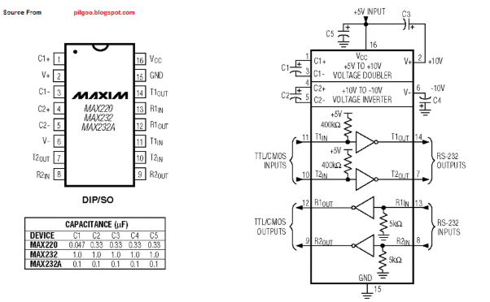**1)RS232 IC**

The RS-232 IC is a key component for serial communication, providing a standard interface to transmit and receive data between devices like microcontrollers and computers. It converts the voltage levels between the RS-232 protocol and the TTL logic used by microcontrollers, ensuring compatibility and reliable data exchange.

**2) 5mm LDR (Light-Dependent Resistor)**

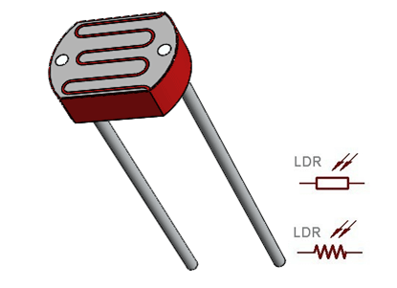The LDR is a crucial sensor for detecting the intensity of sunlight. Its resistance varies inversely with light intensity, making it ideal for measuring the Sun's position. Multiple LDRs are used in this project to provide feedback on sunlight direction for dual-axis tracking.

**3)Jumper Wires**

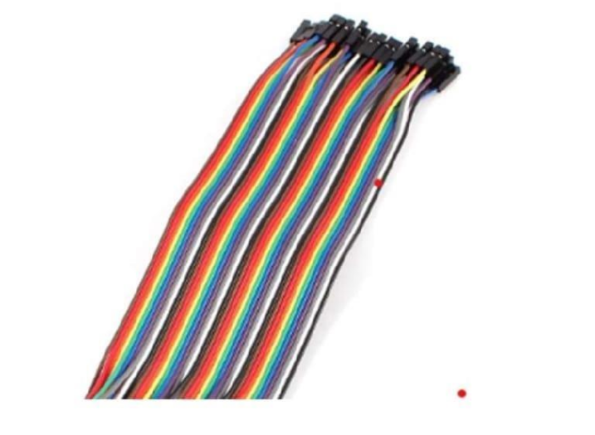Jumper wires are flexible connectors used to establish temporary links between components on a breadboard or within a circuit. These wires come in different configurations—male-to-male, male-to-female, and female-to-female—making them versatile for prototyping and testing various electronic setups.

**4) 12V DC Motor**

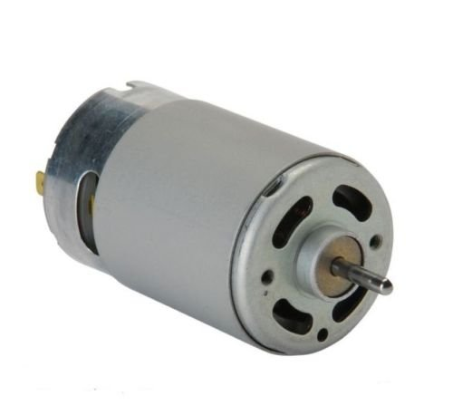The 12V DC motors are responsible for adjusting the solar panel's position along horizontal and vertical axes. Controlled via the motor driver, these motors ensure precise movement, allowing the panel to follow the Sun throughout the day for maximum efficiency.

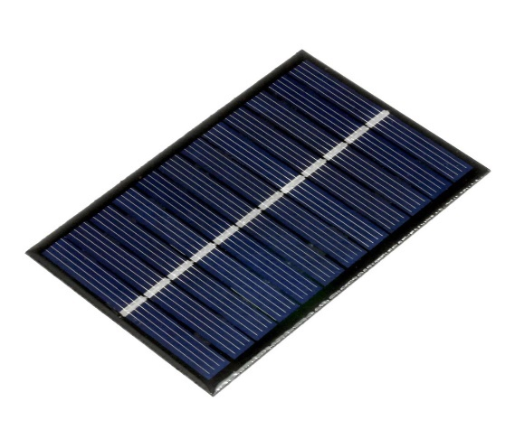**5)5V Solar Panel**

The solar panel not only serves as the core component for energy harvesting but also demonstrates the effectiveness of the dual-axis tracking system. Its alignment is constantly optimized by the system to maximize power output throughout the day.

**6)LM293D Motor Driver**

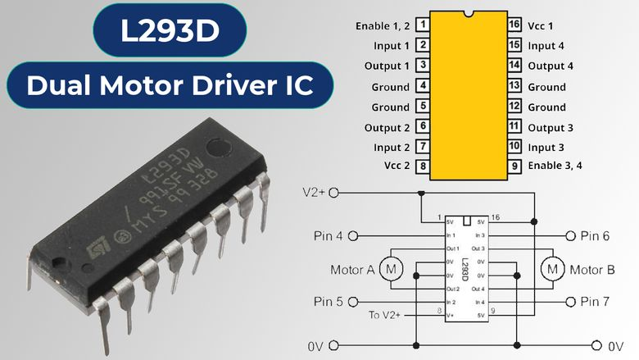The motor driver acts as an interface between the microcontroller and the motors. It amplifies the control signals and provides the necessary current to drive the motors, supporting both forward and reverse operation for precise panel positioning

**7)12V Battery**

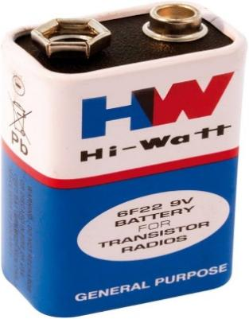The battery powers the entire system, providing a stable voltage supply for the motors and electronic components. It ensures continuous operation, even in fluctuating power conditions.

1. **OP-AMP**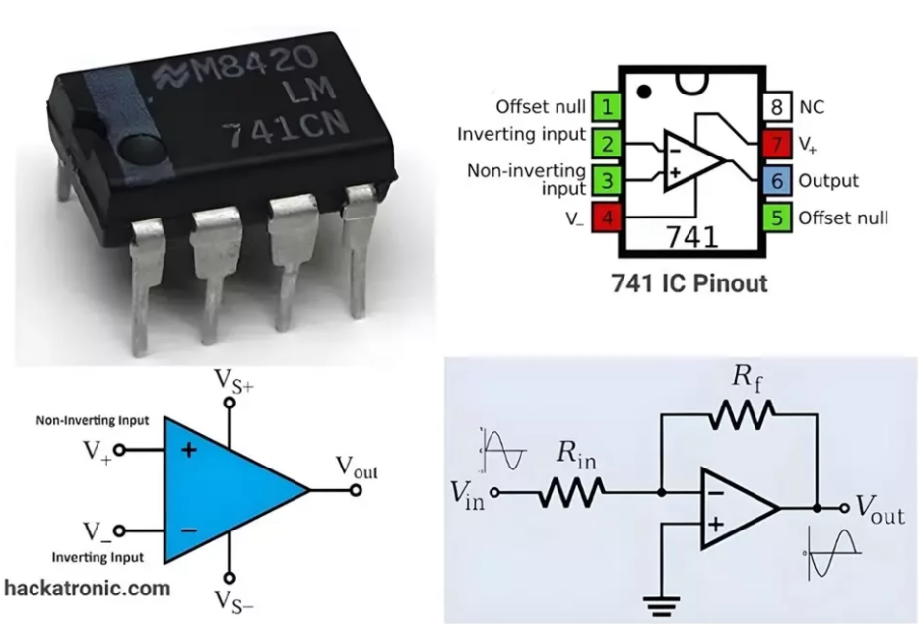The operational amplifier is used to process and amplify the small voltage signals from LDRs, ensuring accurate detection and input for the microcontroller. This component is critical for precise Sun tracking based on sensor feedback.

**VI.BLOCK DIAGRAM DESCRIPTION:**

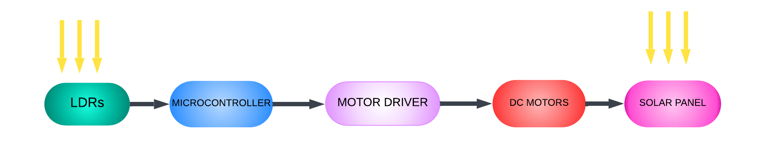

This block diagram illustrates the working of a Dual-Axis Sun Tracking Solar Panel system. The system is designed to automatically adjust the position of a solar panel to track the sun throughout the day, maximizing its energy output.

* LDRs (Light Dependent Resistors : These sensors detect the intensity of sunlight falling on them. By measuring the light intensity from different angles, the LDRs help in determining the best position for the solar panel.
* Microcontroller: The microcontroller receives the input from the LDRs and processes it to decide the required movement for the solar panel. It sends control signals to the motors based on the data received from the LDRs, ensuring the panel is always aligned with the sun.
* Motors: These motors adjust the position of the solar panel in both the horizontal (azimuth) and vertical (elevation) axes, enabling it to follow the sun's movement from sunrise to sunset. The motors adjust the panel’s angle to achieve maximum exposure to sunlight at all times.
* Solar Panel: The panel captures sunlight and converts it into electrical energy. The continuous tracking ensures the panel receives optimal sunlight, enhancing its energy production efficiency.
* Energy Capture: This represents the energy generated by the solar panel, which is either stored in batteries for later use or used directly to power connected systems.

This automated sun tracking system enhances the performance of the solar panel, increasing energy efficiency and ensuring maximum power generation throughout the day.

**VII.ALGORITHM USED:**

**;====================================================================**

**; Main.asm file with two DC motors controlled by four LDRs**

**;**

**; Created: Wed Nov 13 2024**

**; Processor: AT89C51**

**; Compiler: ASEM-51 (Proteus)**

**;====================================================================**

**$NOMOD51**

**$INCLUDE (8051.MCU) ; Include standard 8051 definitions**

**;====================================================================**

**; DEFINITIONS**

**;====================================================================**

**MOTOR1_A EQU P2.0 ; Motor 1 control pin A**

**MOTOR1_B EQU P2.1 ; Motor 1 control pin B**

**MOTOR2_A EQU P2.2 ; Motor 2 control pin A**

**MOTOR2_B EQU P2.3 ; Motor 2 control pin B**

**;====================================================================**

**; RESET and INTERRUPT VECTORS**

**;====================================================================**

**ORG 0H**

**MOV P1, #0FFH ; Set Port 1 as input for LDR sensors**

**MOV P2, #00H ; Initialize Port 2 (Motor control lines)**

**;====================================================================**

**; MAIN PROGRAM**

**;====================================================================**

**BACK:**

**MOV P2, #00H ; Stop both motors initially**

**; Motor 1 control based on LDRs connected to P1.0 and P1.1**

**JB P1.0, MOTOR1_CHECK_P1_1 ; If P1.0 (LDR 1) is high, check P1.1**

**JB P1.1, MOTOR1_CHECK_P1_0 ; If P1.1 (LDR 2) is high, check P1.0**

**SJMP MOTOR1_RESET ; If both are low, reset Motor 1**

**MOTOR1_CHECK_P1_1:**

**JB P1.1, MOTOR1_STOP ; If both LDRs are high, stop Motor 1**

**SJMP MOTOR1_ANTICLOCKWISE ; If only P1.0 is high, rotate Motor 1 anticlockwise**

**MOTOR1_CHECK_P1_0:**

**JB P1.0, MOTOR1_STOP ; If both LDRs are high, stop Motor 1**

**SJMP MOTOR1_CLOCKWISE ; If only P1.1 is high, rotate Motor 1 clockwise**

**MOTOR1_STOP:**

**CLR MOTOR1_A ; Stop Motor 1**

**CLR MOTOR1_B**

**SJMP MOTOR2_CONTROL ; Proceed to Motor 2 control**

**MOTOR1_CLOCKWISE:**

**SETB MOTOR1_A ; Set Motor 1 to rotate clockwise**

**CLR MOTOR1_B**

**ACALL DELAY ; Call delay subroutine**

**SJMP MOTOR2_CONTROL**

**MOTOR1_ANTICLOCKWISE:**

**CLR MOTOR1_A ; Set Motor 1 to rotate anticlockwise**

**SETB MOTOR1_B**

**ACALL DELAY ; Call delay subroutine**

**SJMP MOTOR2_CONTROL**

**MOTOR1_RESET:**

**CLR MOTOR1_A ; Reset Motor 1**

**CLR MOTOR1_B**

**SJMP MOTOR2_CONTROL ; Proceed to Motor 2 control**

**;====================================================================**

**; MOTOR 2 CONTROL**

**;====================================================================**

**MOTOR2_CONTROL:**

**; Motor 2 control based on LDRs connected to P1.2 and P1.3**

**JB P1.2, MOTOR2_CHECK_P1_3 ; If P1.2 (LDR 3) is high, check P1.3**

**JB P1.3, MOTOR2_CHECK_P1_2 ; If P1.3 (LDR 4) is high, check P1.2**

**SJMP MOTOR2_RESET ; If both are low, reset Motor 2**

**MOTOR2_CHECK_P1_3:**

**JB P1.3, MOTOR2_STOP ; If both LDRs are high, stop Motor 2**

**SJMP MOTOR2_CLOCKWISE ; If only P1.2 is high, rotate Motor 2 clockwise**

**MOTOR2_CHECK_P1_2:**

**JB P1.2, MOTOR2_STOP ; If both LDRs are high, stop Motor 2**

**SJMP MOTOR2_ANTICLOCKWISE ; If only P1.3 is high, rotate Motor 2 anticlockwise**

**MOTOR2_STOP:**

**CLR MOTOR2_A ; Stop Motor 2**

**CLR MOTOR2_B**

**SJMP BACK ; Return to main loop**

**MOTOR2_CLOCKWISE:**

**SETB MOTOR2_A ; Set Motor 2 to rotate clockwise**

**CLR MOTOR2_B**

**ACALL DELAY ; Call delay subroutine**

**SJMP BACK**

**MOTOR2_ANTICLOCKWISE:**

**CLR MOTOR2_A ; Set Motor 2 to rotate anticlockwise**

**SETB MOTOR2_B**

**ACALL DELAY ; Call delay subroutine**

**SJMP BACK**

**MOTOR2_RESET:**

**CLR MOTOR2_A ; Reset Motor 2**

**CLR MOTOR2_B**

**SJMP BACK ; Return to main loop**

**;====================================================================**

**; DELAY SUBROUTINE**

**;====================================================================**

**DELAY:**

**MOV R0, #255 ; Initialize delay counter**

**HERE: DJNZ R0, HERE ; Decrement counter and repeat**

**RET ; Return from subroutine**

**END**

**VIII.ASSEMBLY CODE EXPLAINED:**

1. Pin Assignments:
   * MOTOR1_A and MOTOR1_B control Motor 1's directions.
   * MOTOR2_A and MOTOR2_B control Motor 2's directions.
   * LDRs are connected to Port 1 (P1.0, P1.1 for Motor 1; P1.2, P1.3 for Motor 2).
2. Main Program:
   * Motor 1 Control: The program reads LDR inputs at P1.0 and P1.1. Based on the LDR states:
     + If both are low, Motor 1 stops.
     + If one is high, it makes Motor 1 rotate in either clockwise or anticlockwise direction.
     + If both are high, Motor 1 stops.
   * The corresponding logic for Motor 2 is handled in a similar manner, reading LDRs at P1.2 and P1.3.
3. Motor Control:
   * Motor control is achieved by setting or clearing the respective pins (MOTOR1_A, MOTOR1_B, MOTOR2_A, MOTOR2_B) for clockwise or anticlockwise motion.
   * A DELAY subroutine is used to create a pause for motor movement before checking for the next state.
4. Reset and Stop Logic:
   * Motors are reset (stop) whenever both LDRs are low.
   * The program continuously checks and controls the motors based on LDR readings in a loop.
5. Delay Subroutine:
   * The DELAY subroutine creates a time delay using a decrementing loop with a register (R0) to slow down motor actions, providing time for each action to be observed before the next check occurs.

This program effectively simulates a simple light-following system for two motors using LDRs.

**Assumption:** The difference in light intensity between opposing LDRs is above the threshold, causing movement.

|  |  |  |  |  |  |
| --- | --- | --- | --- | --- | --- |
| **LEFT LDR INTENSITY** | **RIGHT LDR INTENSITY** | **TOP LDR INTENSITY** | **BOTTOM LDR INTENSITY** | **HORIZONTAL MOVEMENT** | **VERTICAL MOVEMENT** |
| HIGH | LOW | LOW | LOW | TURNS LEFT | NO MOVEMENT |
| LOW | HIGH | LOW | LOW | TURNS RIGHT | NO MOVEMENT |
| LOW | LOW | HIGH | LOW | NO MOVEMENT | TURNS UP |
| LOW | LOW | LOW | HIGH | NO MOVEMENT | TURNS DOWN |
| HIGH | HIGH | HIGH | HIGH | NO MOVEMENT | NO MOVEMENT |
| HIGH | LOW | HIGH | LOW | TURNS LEFT | TURNS UP |
| LOW | HIGH | LOW | HIGH | TURNS RIGHT | TURNS DOWN |

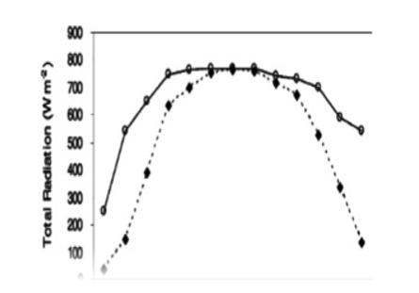

**IX.ISSUES FACED :**

**X.PRACTICAL APPLICATIONS:**

1. **Solar Power Generation**:
   * The primary application is in solar energy generation, where the sun tracking system maximizes the solar panel's exposure to the sun, significantly increasing the energy captured throughout the day. This leads to higher energy efficiency, which is especially beneficial for both residential and commercial solar installations.
2. **Commercial Solar Installations**:
   * For large-scale solar farms, the sun tracking system ensures optimal panel positioning, increasing overall energy output and reducing the number of panels required for the same amount of energy. This improves return on investment (ROI) and makes solar energy more cost-effective for large installations.
3. **Remote and Off-Grid Areas**:
   * In remote or off-grid locations, where access to electricity is limited, the sun tracking solar system provides reliable and efficient energy. This is especially useful for powering homes, communication systems, or medical devices, reducing reliance on fossil fuels and enhancing sustainability in areas without grid infrastructure.

**Conclusion:**

The development of a dual-axis sun tracking solar panel system demonstrates the potential for significantly improving the efficiency of solar energy capture. By utilizing the dynamic positioning of the solar panel in response to the sun’s movement, this system ensures maximum exposure to sunlight, leading to enhanced energy generation. The use of LDRs, motors, and a microcontroller to automate the tracking process provides an efficient, cost-effective solution for optimizing solar energy production.

While conventional fixed solar panels may miss out on optimal sunlight exposure throughout the day, the proposed sun tracking system overcomes this challenge. This design is well-suited for applications that require continuous energy generation and sustainability, making it an ideal choice for both residential and industrial solar energy systems. The project highlights the importance of integrating smart, adaptive technologies in renewable energy solutions to meet growing energy demands.

**BY:-**

**SOUMYA SOURAV (122EE0384)**

**ANUP ASHISH DASH (122EE0595)**

**SANSKRUTI DASH (122EE0596)**